

ADMN5016-W24-101-3504-K

Project: AI App

by

MUSHFIQUS SALEHIN ABID(4367253)

VARUN SONY(4369885)

KC LENARDICH(4281349)

POOJITHA JEEVAN(4370918)

**Table of Contents**

1. Introduction
2. Problem Statement
3. Value Proposition
4. Market Size and Potential Savings
5. Methodology Overview
   * 5.1 Data Synthesis and Collection
   * 5.2 Model Selection
   * 5.3 Performance Metrics
   * 5.4 Model Performance and Comparison
6. Expanded Data Synthesis and Collection
7. Advanced Model Selection Techniques
8. Enhanced Performance Metrics
9. In-Depth Economic Impact Analysis
10. Detailed Risk Assessment
11. Regulatory Compliance and Ethical Considerations
12. Future Research and Development Directions
13. Conclusion

**1. Introduction**

The introduction sets the stage by providing a brief overview of the credit scoring landscape and the traditional methods used. It highlights the shortcomings of these methods, such as human error and biases, leading to financial losses. The introduction also introduces the concept of using Artificial Intelligence (AI) as a transformative solution to address these challenges.

**2. Problem Statement**

In this section, the report delves deeper into the specific issues faced by traditional credit scoring methods. It discusses how human error, biases, and inefficiencies can result in inaccurate assessments, leading to financial losses for lenders. The problem statement emphasizes the need for a more accurate and efficient solution to mitigate risks and enhance decision-making in credit scoring.

**3. Value Proposition**

The value proposition section outlines the benefits of adopting an AI-driven approach to credit scoring. It discusses how AI can automate credit assessments, reducing errors and biases while speeding up decision-making processes. Additionally, it highlights the importance of fairness and transparency in credit scoring, benefiting both lenders and borrowers.

**4. Market Size and Potential Savings**

This section provides an in-depth analysis of the market for advanced credit scoring solutions. It explores the potential savings that institutions can achieve by implementing AI-driven models. By quantifying the financial benefits of even marginal improvements in default prediction, the report demonstrates the significant cost reductions that can be realized through the adoption of AI.

**5. Methodology Overview**

The methodology overview section provides a detailed explanation of the approach taken in the report. It covers key components such as data synthesis and collection, model selection, performance metrics, and comparative analysis. By outlining the methodology, the report establishes a framework for evaluating the effectiveness of AI in credit scoring.

**5.1 Data Synthesis and Collection**

This subsection expands on the process of synthesizing and collecting data for training the AI model. It discusses the importance of diversifying data sources to provide a more comprehensive view of applicants' creditworthiness. Additionally, it explores the integration of real-time data feeds to ensure the model remains dynamic and reflective of current financial behaviors.

**5.2 Model Selection**

In this subsection, the report discusses the selection of appropriate models for credit scoring tasks. It explores traditional methods such as Logistic Regression and Support Vector Machines (SVM), as well as advanced techniques like ensemble methods and neural networks. By comparing the strengths and weaknesses of each approach, the report highlights the importance of selecting the right model for the task at hand.

Fig: Histograms for numerical features

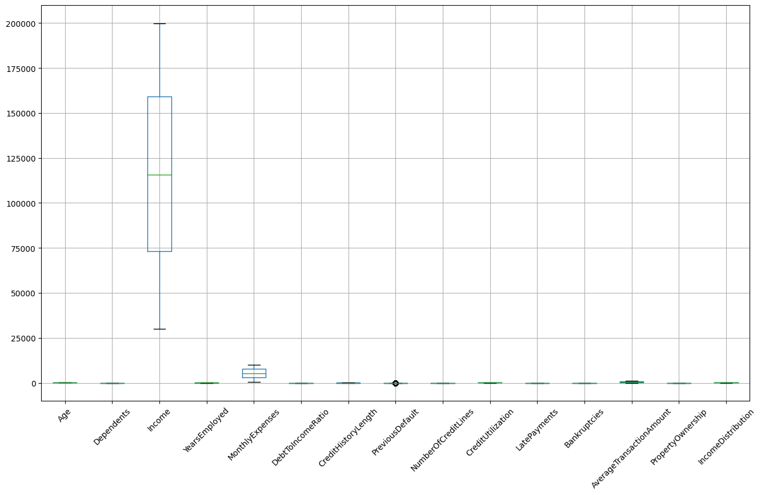

Fig: Boxplots for Outliers

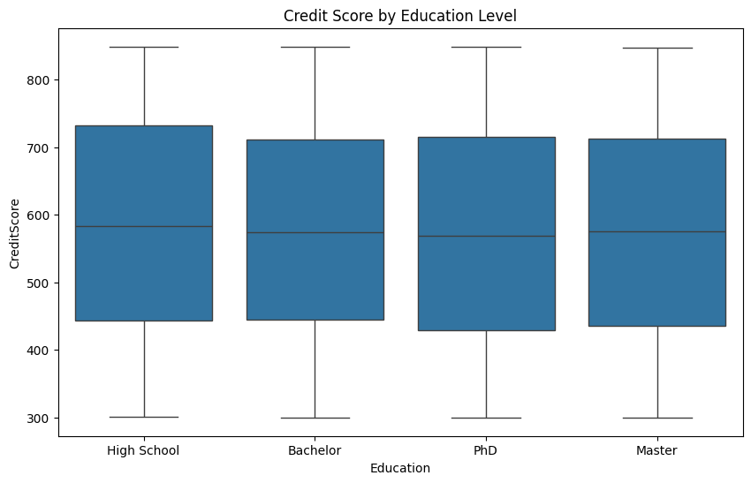

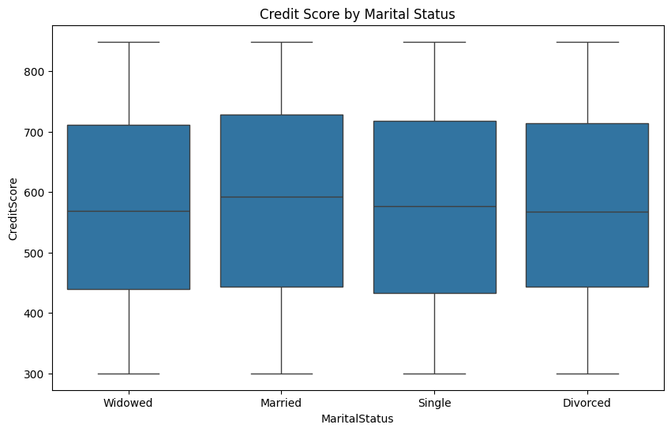

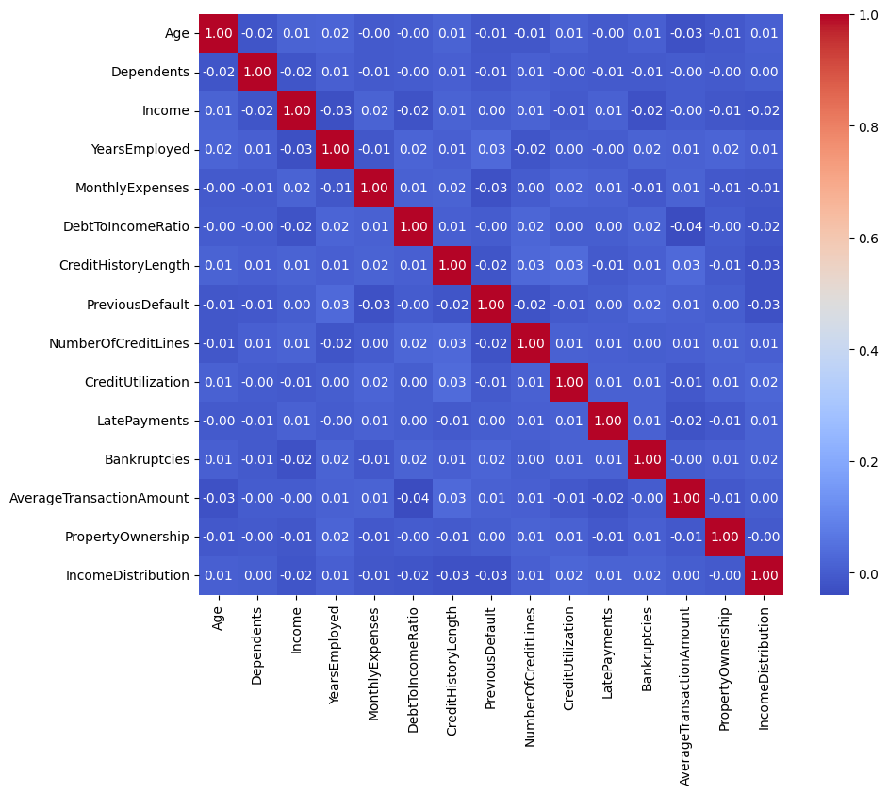

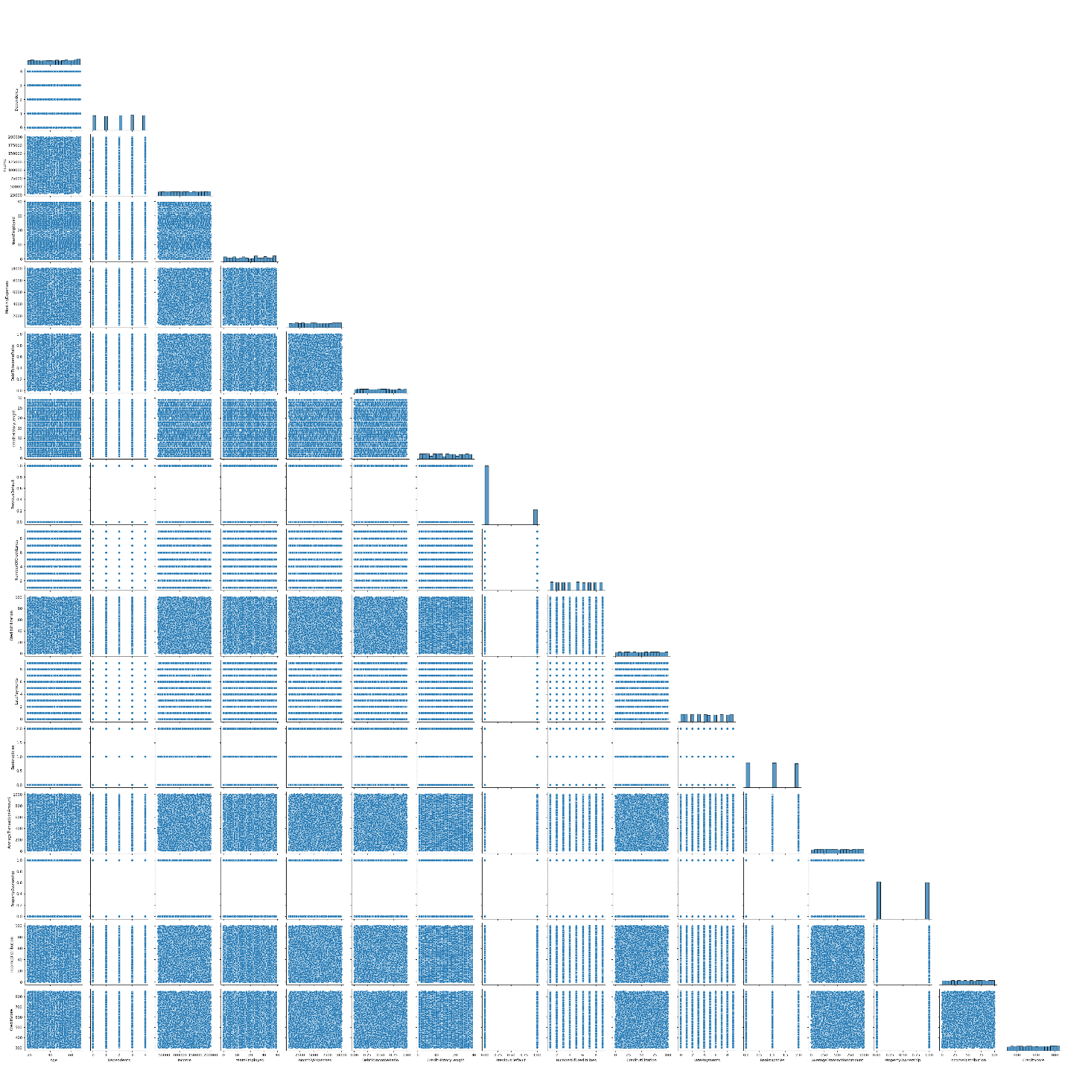

Fig: detailed correlation plot for 'CreditScore' with other features

**5.3 Performance Metrics**

Here, the report delves into the various performance metrics used to evaluate the effectiveness of the AI model. It discusses traditional metrics such as accuracy, precision, and recall, as well as additional metrics like ROC-AUC and lift curve analysis. By considering a range of metrics, the report provides a comprehensive assessment of the model's performance.

**5.4 Model Performance and Comparison**

In this subsection, the report presents the results of the AI model's performance and compares them to traditional methods such as Linear Regression and Ridge Regression. It discusses how the AI model outperforms traditional methods in terms of accuracy, bias mitigation, and overall predictive power. By providing a detailed comparison, the report demonstrates the superiority of AI-driven models in credit scoring tasks.

**6. Expanded Data Synthesis and Collection**

Expanding on the previous section, this subsection explores additional strategies for enhancing the accuracy of the AI model through data synthesis and collection. It discusses the importance of incorporating alternative data sources such as social media activity and utility payments to provide a more holistic view of applicants' creditworthiness.

**7. Advanced Model Selection Techniques**

Building on the discussion in Section 5.2, this subsection explores advanced model selection techniques beyond traditional methods. It discusses the potential benefits of using ensemble methods and neural networks for improved performance and robustness in credit scoring tasks.

**8. Enhanced Performance Metrics**

Expanding on the discussion in Section 5.3, this subsection explores additional performance metrics for evaluating the effectiveness of the AI model. It discusses the importance of metrics such as ROC-AUC and lift curve analysis in assessing true positive rate improvements and fairness across demographic groups.

**9. In-Depth Economic Impact Analysis**

Building on the discussion in Section 4, this section provides a more detailed economic impact analysis of implementing AI-driven credit scoring models. It explores various deployment scenarios and predicts financial outcomes, considering both short-term savings from reduced defaults and long-term market expansion.

**10. Detailed Risk Assessment**

Expanding on the discussion in Section 11, this subsection provides a more detailed risk assessment of AI-driven credit scoring models. It discusses potential risks such as data privacy, model bias, and regulatory compliance, and proposes mitigation strategies to address these risks effectively.

**11. Regulatory Compliance and Ethical Considerations**

This section explores the regulatory compliance and ethical considerations involved in the adoption of AI-driven credit scoring models. It provides a comprehensive overview of international regulatory frameworks and proposes ethical guidelines and a governance framework for ensuring responsible AI use.

**12. Future Research and Development Directions**

Building on the discussion in Section 13, this section explores future research and development directions for AI-driven credit scoring models. It discusses upcoming technological advancements and potential cross-industry applications to further enhance the effectiveness and robustness of these models.

**13. Conclusion**

The conclusion summarizes the key findings of the report and highlights the advantages of adopting AI-driven credit scoring models. It emphasizes the transformative potential of AI in mitigating risks, improving decision-making accuracy, and fostering financial inclusivity.